DIS-Plummets-TN

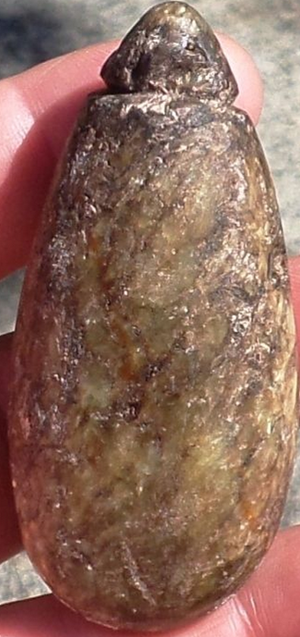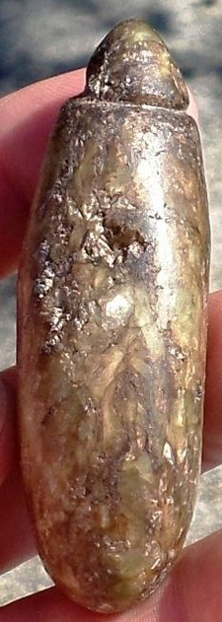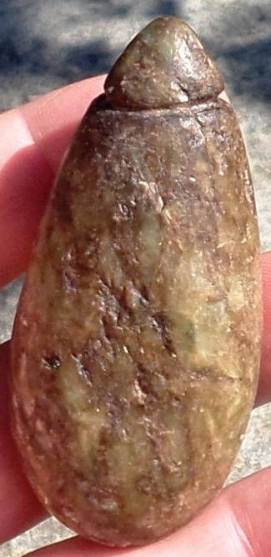

Grooved plummet with a few blemishes but still a nice piece and in good condition. It measures 2 7/8" x 1 5/16”. This plummet is part of a collection from White Pine, Tennessee.

|  |  |  |
| --- | --- | --- |
| [WP2 Grooved Stone Plummet Native American Relic Indian Artifact Pendant](http://www.ebay.com/itm/171969755160?_trksid=p2057872.m2749.l2649&ssPageName=STRK%3AMEBIDX%3AIT)  ( 171969755160 )  Estimated delivery Wed, Oct 28  [Add note](javascript:;) | ITEM PRICE:  US $17.00 | **Item WP2 Grooved Stone Plummet Native American Relic Indian Artifact Pendant Orders 171969755160-0-0**[Leave feedback](http://feedback.ebay.com/ws/eBayISAPI.dll?LeaveFeedbackShow&useridto=tnreliccollector&transactID=0&item=171969755160&_trksid=p2057872.m2749.l2665)[Return this item](http://postorder.ebay.com/Return/ReturnViewSelectedItem?transactionId=0&itemId=171969755160&_trksid=p2057872.m2749.l3185)  [More actions](http://www.ebay.com/myb/PurchaseHistory) |